**Turn On/Off Device**

Actor-context diagram:

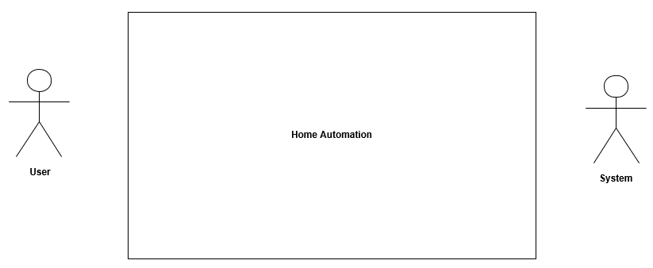

Use case diagram:

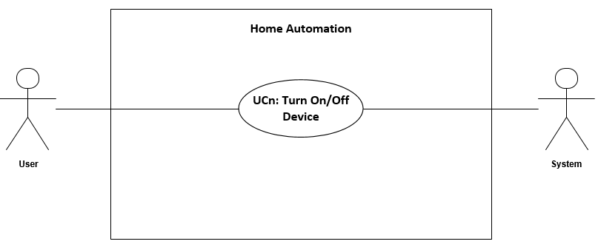

**Fully-dressed use case:**

UCn: Turn On/Off Device

**Goal:** Gives the user the opportunity to turn on/off a device

**Initialization:** User

**Actors:**

*User – primary:* Wants to turn on/off a device

*System – secondary:* Completes the data input from user

**Reference:** None

**Simultaneous occurrences:** None

**Condition:** The system is operational and the GUI is available

**Result:** User turns on/off device

**Main scenario:**

1. User choose device from the GUI
2. User turns on/off device from the GUI
3. System completes the request